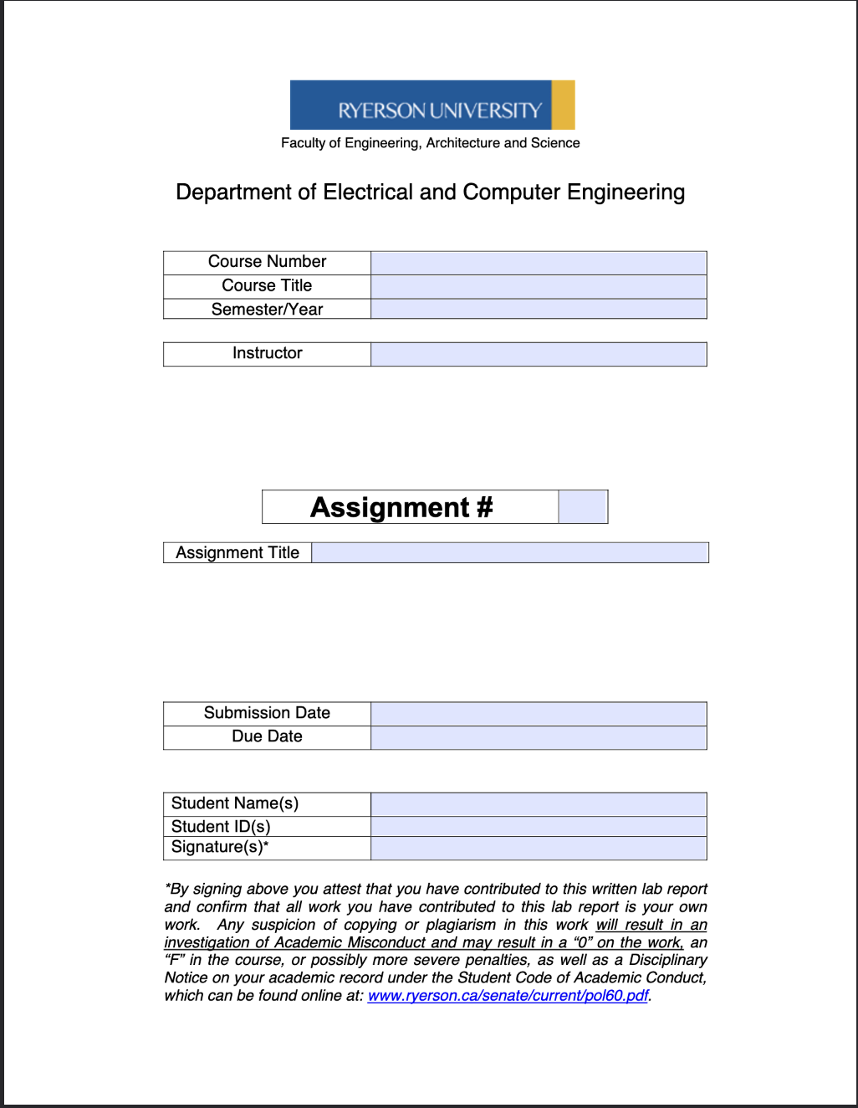
ELE504
Electronic Circuits II
F2024
Dr. Rueda
MP
ELE504 Major Project Pre-Lab 1
October 1st, 2024
October 2nd, 2024
Shai Mourad
501170415
SM

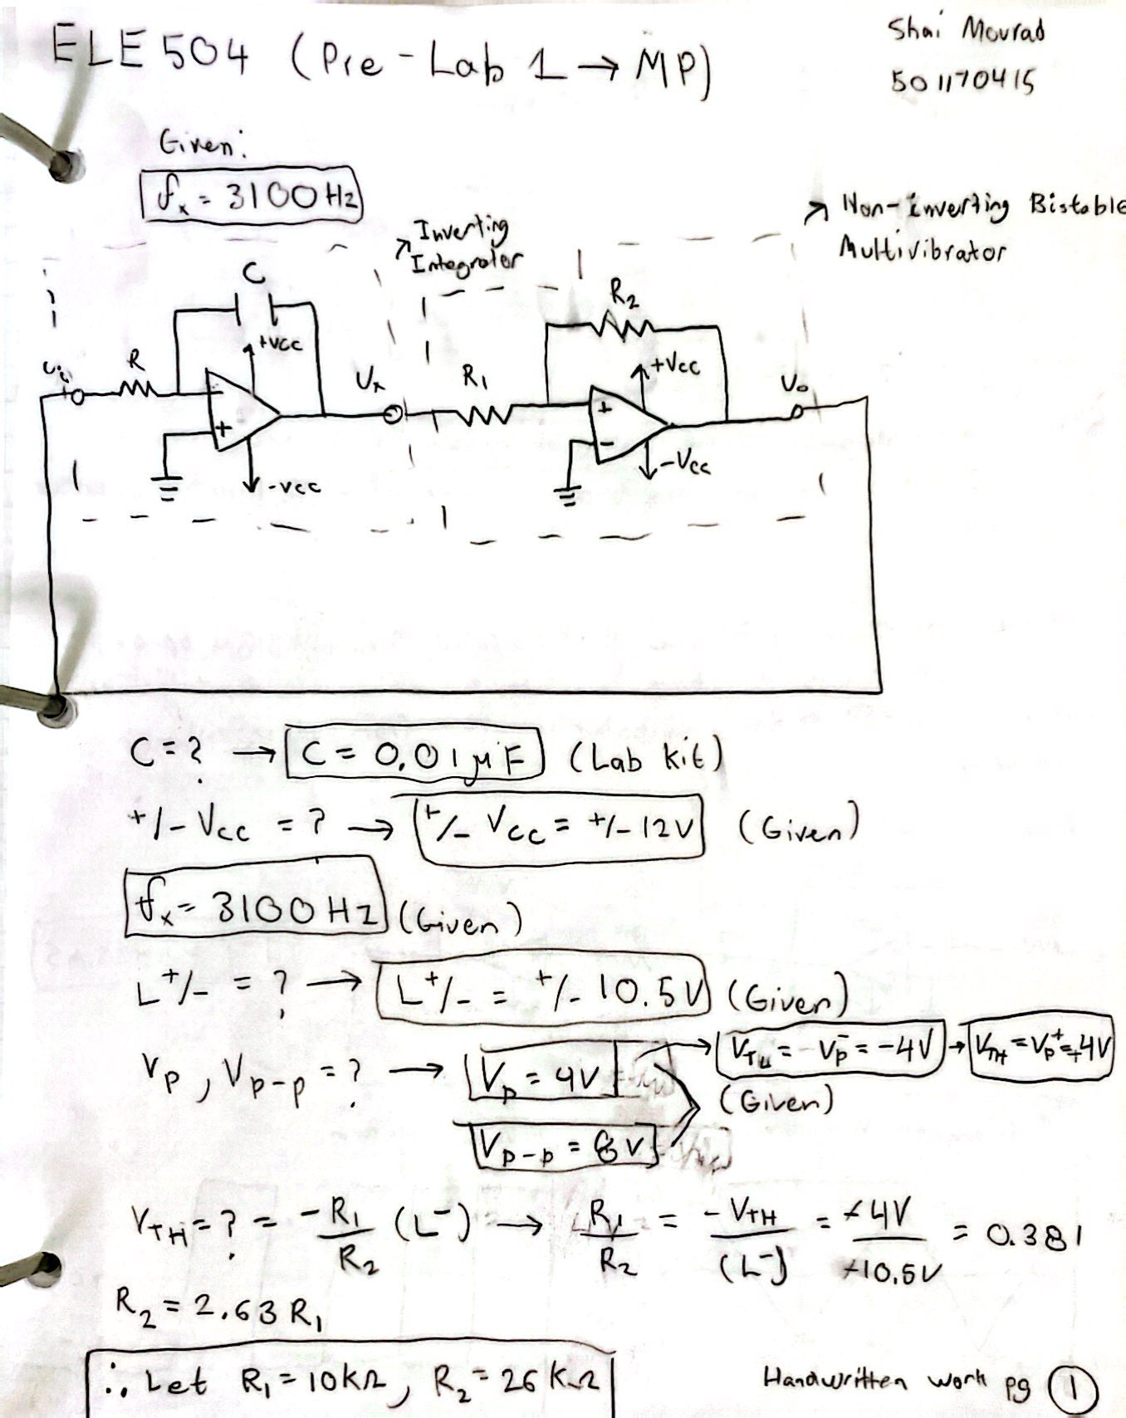

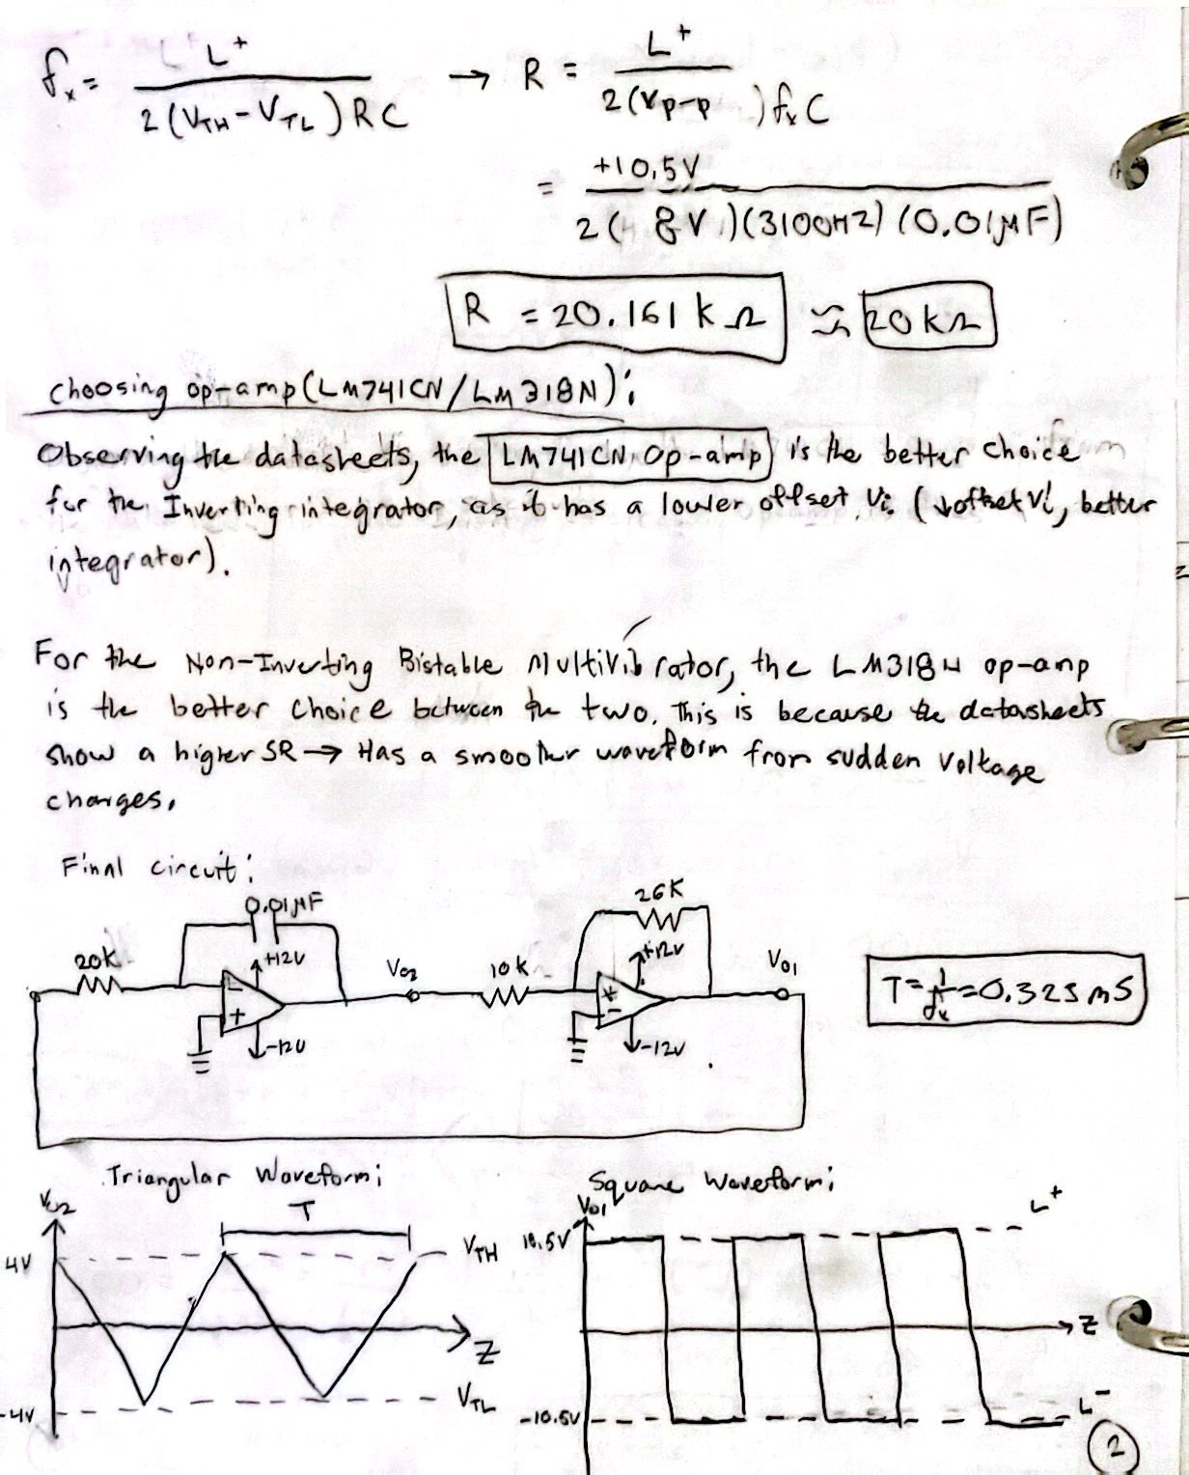

Multisim Section:
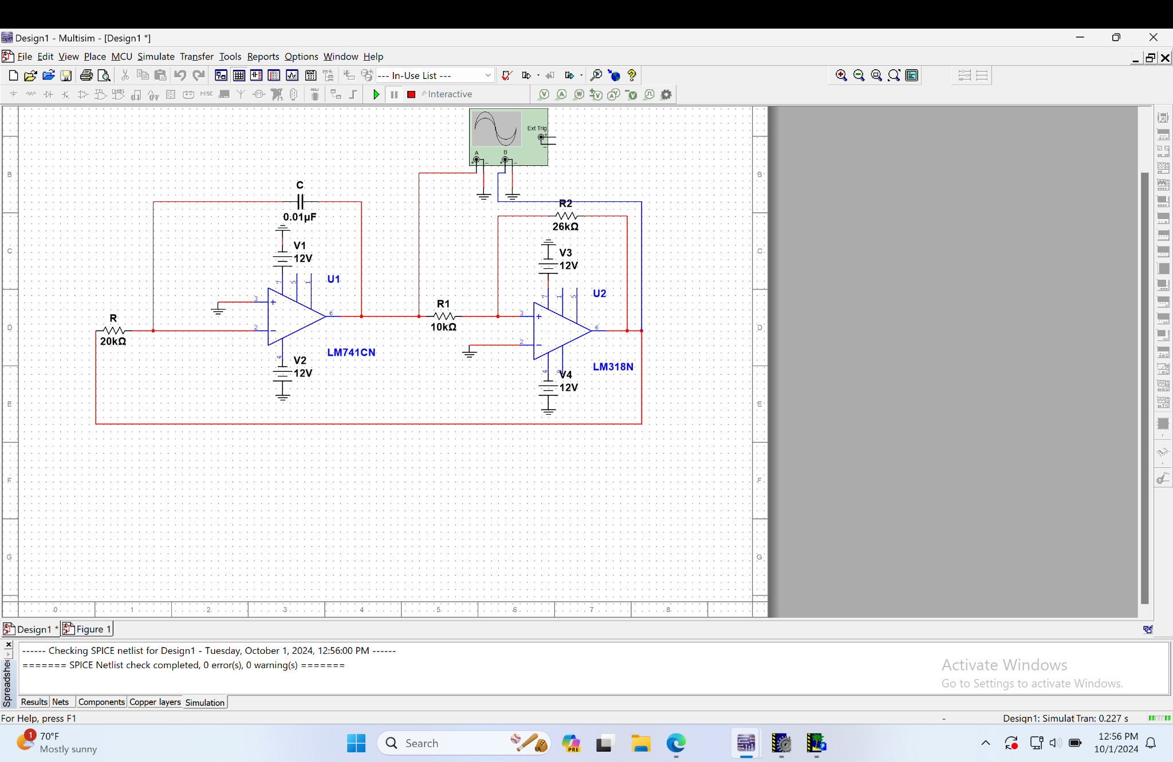
Simulation of Waveform Generator Design in Multisim.

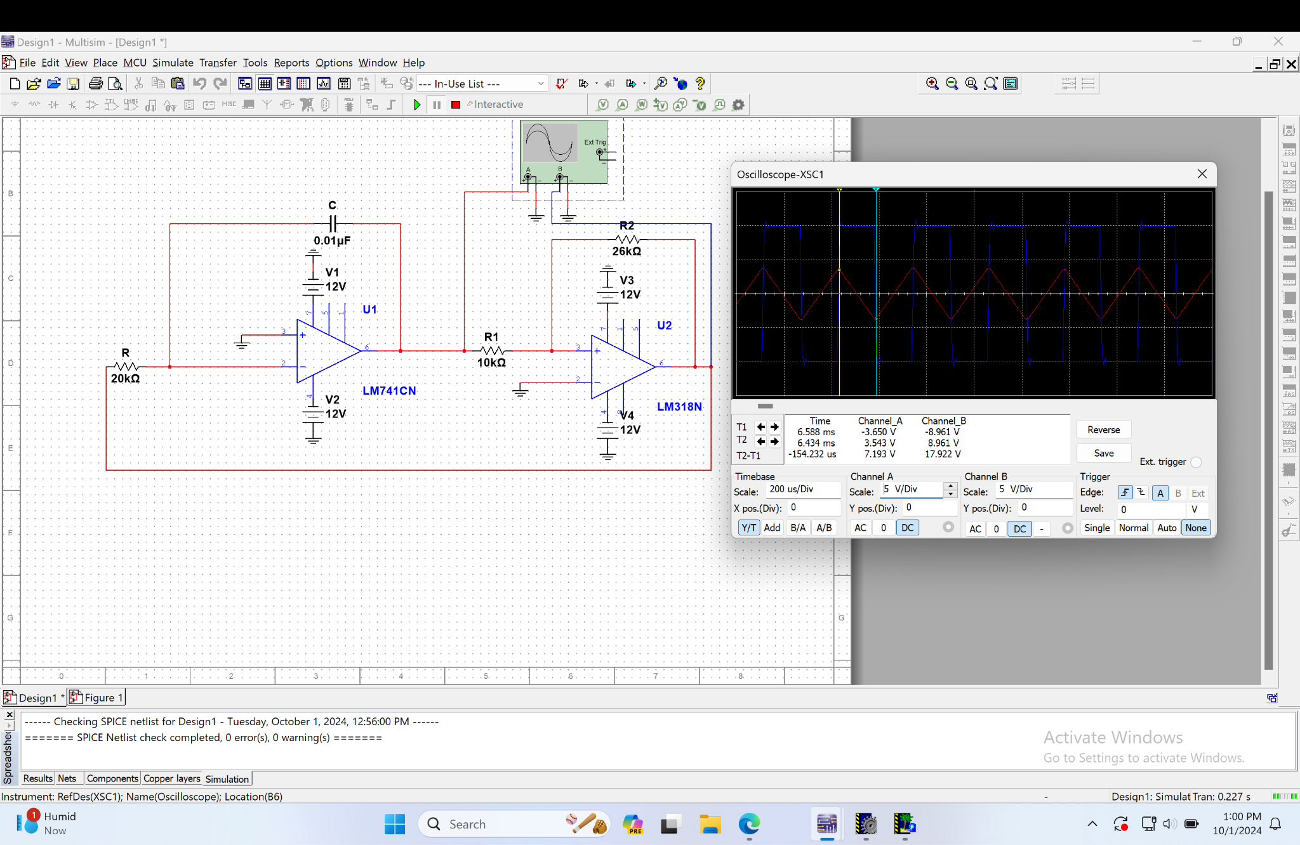
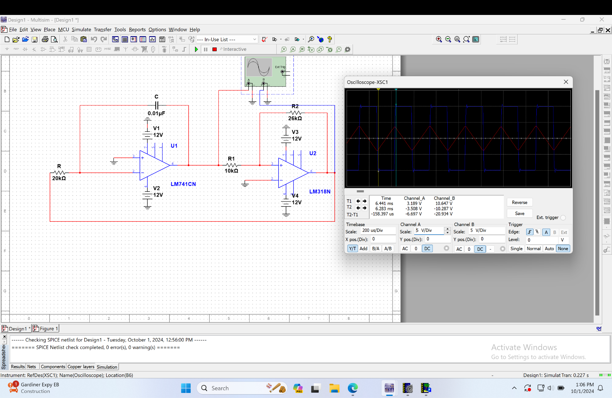
Simulations of the Waveforms of Design in Multisim (1st image - V_{O2} readings, 2nd image - V_{O1} readings)

Square Waveform (V_{O1}) | Pre-Lab | Simulation
V⁺_{p} | 10.5V | 10.647V
V⁻_{p} | -10.5V | -10.287V
T | 0.323ms | 0.317ms
f_{x} = $\frac{1}{T}$ | 3100Hz | 3154.57Hz
Table 1a. Comparing Pre-Lab and Multisim Simulation Values for V_{O1}

Triangular Waveform (V_{O2}) | Pre-Lab | Simulation
V⁺_{p} | 4V | 3.543V
V⁻_{p} | -4V | -3.650V
T | 0.323ms | 0.308ms
f_{x} | 3100Hz | 3144.65Hz
Table 1b. Comparing Pre-Lab and Multisim Simulation Values for V_{O2}

As seen from the tables 1a and 1b, the pre-lab calculations match the values from the Multisim simulation. Additionally, the drawn graphs and the simulation waveforms are similar in appearance.

